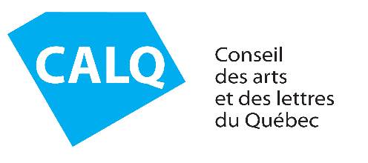 | Modification of Project Dates - COVID-19

Financial aid recipients may request a change to their project dates if exceptional circumstances or those beyond their control delay the project.
Once your application has been analyzed and accepted by the person responsible for your file at the CALQ, the new project end date will appear in your online file.

SECTION 1 – IDENTIFICATION
CALQ file number | Last name and first name
Email address |  |  | Phone number
Project title
Project dates  (initially planned) | From to | New dates: | From to

Section 2 – REASON FOR THE REQUEST
Documents to attach, if applicable
New project schedule.
Any other document to support the application for postponement (e.g., confirmation letter from the partner for a change of presentation dates, change of dates to access a workshop or recording studio, etc.)
SENDING THE FORM
Please return the completed form by email along with all required documents to the individual responsible for your file at the CALQ.

I understand that the use of email offers no guarantee of confidentiality, and I accept the risk of sending personal information by email.
The CALQ confirms that personal information collected in this way is accessible only to individuals authorized to receive it within the organization. The CALQ will use only the information required to follow up on or respond to your message.

FOR CALQ USE ONLY
Application eligible |  | Yes No
Approval |  | Yes No
 | Program officer |  | Signature |  |  | Date

