Conseil des arts et des lettres du Québec
Call for proposals for a work of art at the BAnQ Rouyn-Noranda: additional information

Archival resources :

All of the archival collections kept at BAnQ Rouyn-Noranda are accessible on Advitam (research and dissemination interface of the National Archives) here

Suggestions of archival collections that could be used in the course of this call for projects.

Collection | Contents | Description in Pistard
P34 – Rouyn-Noranda 1925-1976 50th anniversary Committee Collection | This beautiful collection of photos and interviews with pioneers offers a great deal of information about the foundation and development of the cities of Rouyn and Noranda. All photos and interviews are available online at BAnQ numérique. | P34S2  P34S3
P117 – Rouyn-Noranda Historical Society Collection | This is a superb collection of photos of Rouyn-Noranda infrastructure with high-quality maps and plans. | P117S2
P123,S1 – Fonderie Horne, Série Vavasour & Dick Collection | Hubert Vavasour was the first professional photographer to settle in Rouyn-Noranda. He photographed the two cities from their foundation until 1935. | P123S1
P124 – Joseph Hermann Bolduc Collection | Joseph Hermann Bolduc was Rouyn-Noranda’s most prominent photographer from 1937 to 1978. | P124

Location:

The work of art will be installed in the public space occupied by BAnQ Rouyn-Noranda (27 Rue du Terminus Ouest, Rouyn-Noranda) in the Administration and Exhibition area near the main entrance. The space reserved for the work of art is indicated in blue on the following plan.

The floor space available is 200 X 66 cm (13,200 cm²) and the wall space is 200 X 275 cm (55,000 cm²), totally around 3.63 cubic metres.

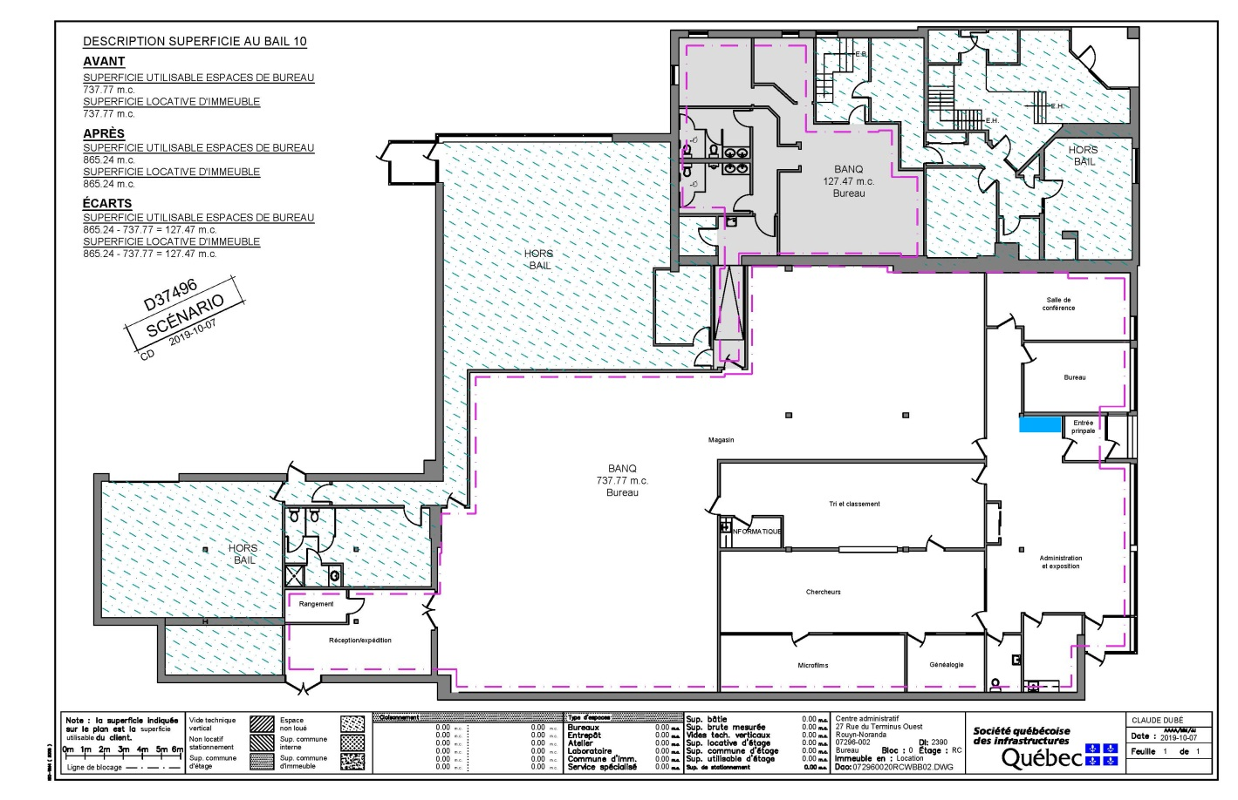

Photos of the space reserved for the piece:

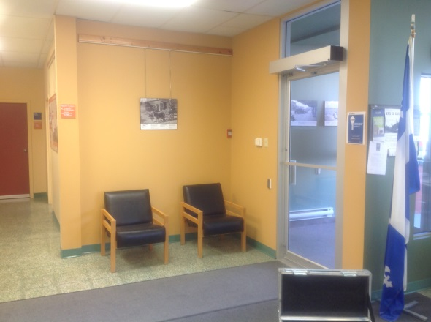 | 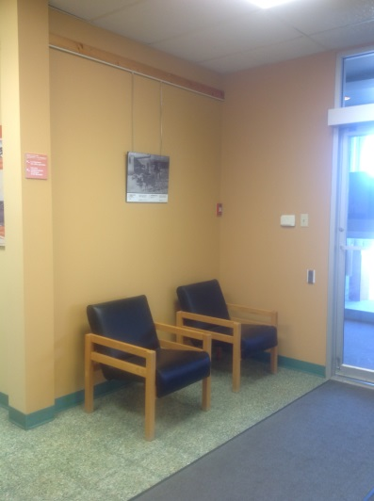

Archivist’s contact information:

Sébastien Tessier
Archivist and Coordinator
Direction des régions
Bibliothèque et Archives nationales du Québec

BAnQ Rouyn-Noranda
27 Rue du Terminus Ouest
Rouyn-Noranda, Québec J9X 2P3
Telephone: 819 763-3484, ext. 6301
Fax: 819 763-3480
sebastien.tessier@banq.qc.ca

